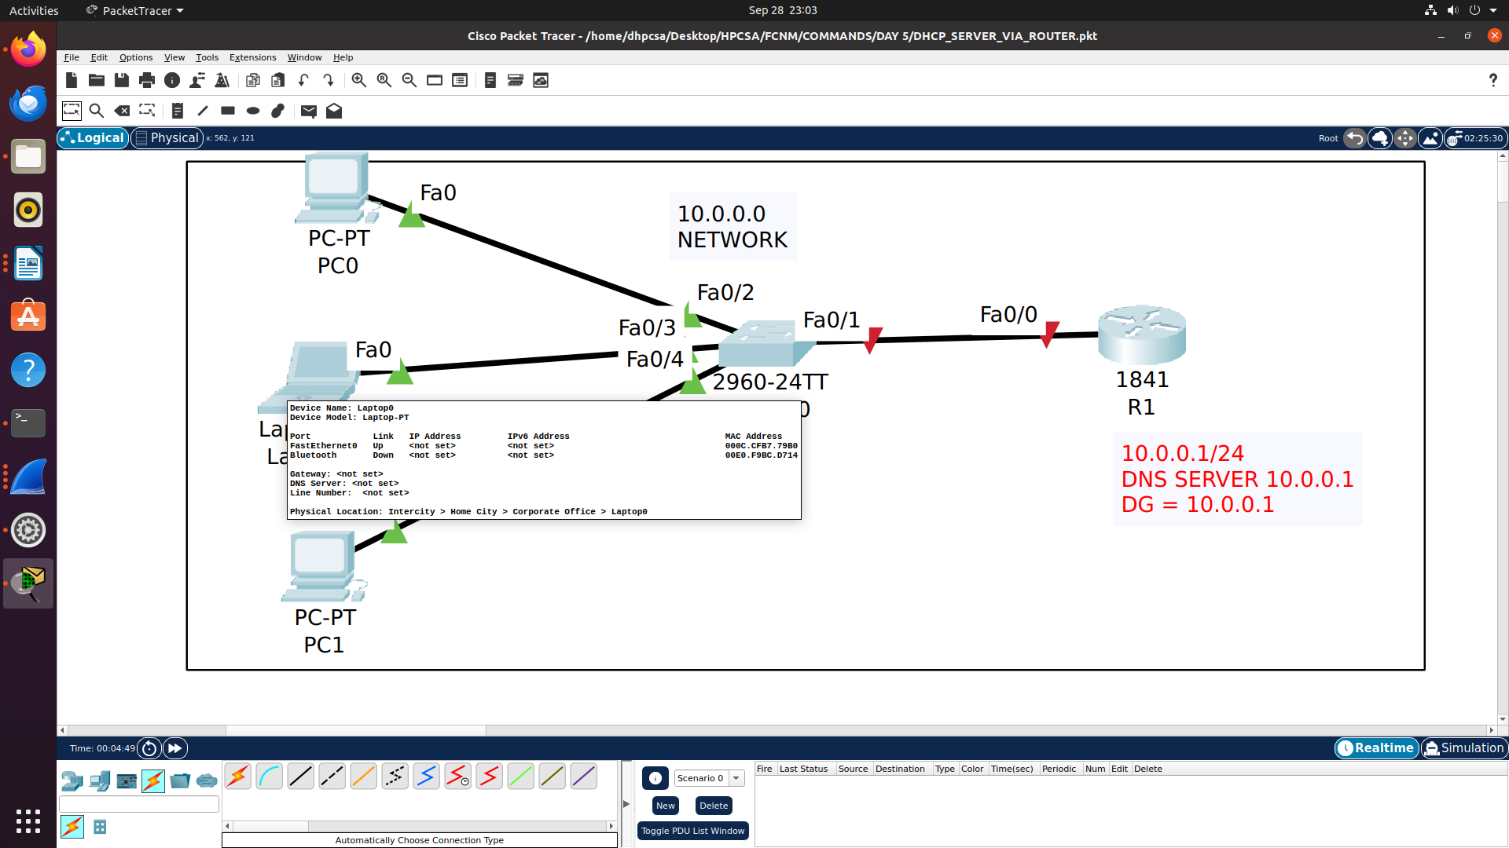

Router(config)#interface FastEthernet0/0
Router(config-if)#ip address 10.0.0.1 255.255.255.0
Router(config-if)#no shutdown
Router(config-if)#exit
r1(config)#HOSTNAME R1

DHCP CONFIG ON ROUTER

R1(config)#ip dhcp pool hpcsa

R1(dhcp-config)#network 10.0.0.0 255.255.255.0

R1(dhcp-config)#default-router 10.0.0.1

R1(dhcp-config)#dns-server 10.0.0.1

R1#sh ip dhcp pool

Pool hpcsa :
Utilization mark (high/low) : 100 / 0
Subnet size (first/next) : 0 / 0
Total addresses : 254
Leased addresses : 3
Excluded addresses : 0
Pending event : none

1 subnet is currently in the pool
Current index IP address range Leased/Excluded/Total
10.0.0.1 10.0.0.1 - 10.0.0.254 3 / 0 / 254

R1#sh ip dhcp binding
IP address Client-ID/ Lease expiration Type
Hardware address
10.0.0.2 0001.C736.8DD6 -- Automatic
10.0.0.3 000C.CFB7.79B0 -- Automatic
10.0.0.4 0004.9AAA.A3D1 -- Automatic

